Project Planning Phase
Project Planning Template (Product Backlog, Sprint Planning, Stories, Story points)

Date | 25 September 2026
Team ID | SWTID-2026-9989
Project Name | Script-Controlled ACL – Restrict Record Access Based on Field Value
Maximum Marks | 5 Marks

Product Backlog, Sprint Schedule, and Estimation (4 Marks)
Use the below template to create product backlog and sprint schedule
Sprint | Functional Requirement (Epic) | User Story Number | User Story / Task | Story Points | Priority | Team Members
Sprint-1 | Table Setup | USN-1 | As an administrator, I can create the Secure Records table with Title, Description and Owner fields so that records can be stored. | 3 | High | Dheepak Karthik S
Sprint-1 | Table Setup | USN-2 | As an administrator, I can add a Classification field (Public / Internal / Confidential) so that access can depend on its value. | 2 | High | Dheepak Karthik S
Sprint-1 | Role & User Management | USN-3 | As an administrator, I can create the role u_confidential_viewer so that authorised people can be identified. | 1 | High | Boopathi S
Sprint-1 | Role & User Management | USN-4 | As an administrator, I can create test users and assign roles so that every scenario can be tested. | 2 | Medium | Boopathi S
Sprint-1 | Record Entry | USN-5 | As a record owner, I can create records and set their Classification so that sensitive data is labelled. | 3 | High | Dineshkumar A
Sprint-2 | Script-Controlled ACL | USN-6 | As an administrator, I can create a read ACL with a script so that visibility depends on the Classification value. | 5 | High | Dheepak Karthik S
Sprint-2 | Script-Controlled ACL | USN-7 | As an administrator, I can create write and create ACLs with the same rule so that Confidential records cannot be edited by others. | 3 | High | Bommanasamy S
Sprint-2 | Script-Controlled ACL | USN-8 | As an administrator, I can restrict delete to the admin role so that records are not removed accidentally. | 2 | Medium | Dharshan P
Sprint-2 | Script-Controlled ACL | USN-9 | As an administrator, I can use Security Debugger so that I can see why access was allowed or denied. | 2 | Medium | Dineshkumar A
Sprint-3 | Access Scenarios | USN-10 | As a confidential viewer, I can open Confidential records so that I can do my review work. | 2 | High | Boopathi S
Sprint-3 | Access Scenarios | USN-11 | As a record owner, I can always open my own Confidential records even without the viewer role. | 2 | High | Dharshan P
Sprint-3 | Access Scenarios | USN-12 | As a standard user, I see only Public and Internal records in the list so that sensitive data stays hidden. | 3 | High | Bommanasamy S
Sprint-3 | Access Scenarios | USN-13 | As a standard user, I am denied when I open a Confidential record by its direct link. | 2 | High | Dineshkumar A
Sprint-3 | Verification | USN-14 | As an administrator, I can change a record's Classification and see visibility update immediately. | 3 | Medium | Dharshan P
Sprint-4 | Testing & Release | USN-15 | As an administrator, I can run UAT and log results so that the solution is accepted. | 3 | Medium | Dineshkumar A
Sprint-4 | Testing & Release | USN-16 | As an administrator, I can export an Update Set and push the scripts to GitHub so that the work is backed up. | 2 | Medium | Dheepak Karthik S
Sprint-4 | Documentation | USN-17 | As a team, we can complete the project report and demo so that the project can be submitted. | 5 | Medium | All team members
Project Tracker, Velocity & Burndown Chart: (4 Marks)
Sprint | Total Story Points | Duration | Sprint Start Date | Sprint End Date (Planned) | Story Points Completed (as on Planned End Date) | Sprint Release Date (Actual)
Sprint-1 | 11 | 6 Days | 24 Aug 2026 | 29 Aug 2026 | 11 | 29 Aug 2026
Sprint-2 | 12 | 6 Days | 31 Aug 2026 | 05 Sep 2026 | 12 | 05 Sep 2026
Sprint-3 | 12 | 6 Days | 07 Sep 2026 | 12 Sep 2026 | 12 | 12 Sep 2026
Sprint-4 | 10 | 6 Days | 14 Sep 2026 | 19 Sep 2026 | 10 | 19 Sep 2026
Velocity:
Our sprint duration is 6 days. Total story points delivered = 11 + 12 + 12 + 10 = 45 over 4 sprints, so team velocity = 45 / 4 = 11.25 story points per sprint. Average velocity per day: AV = velocity / sprint duration = 11.25 / 6 = 1.875 story points per day.
Burndown Chart:
A burn down chart is a graphical representation of work left to do versus time. It is often used in agile software development methodologies such as Scrum. However, burn down charts can be applied to any project containing measurable progress over time.
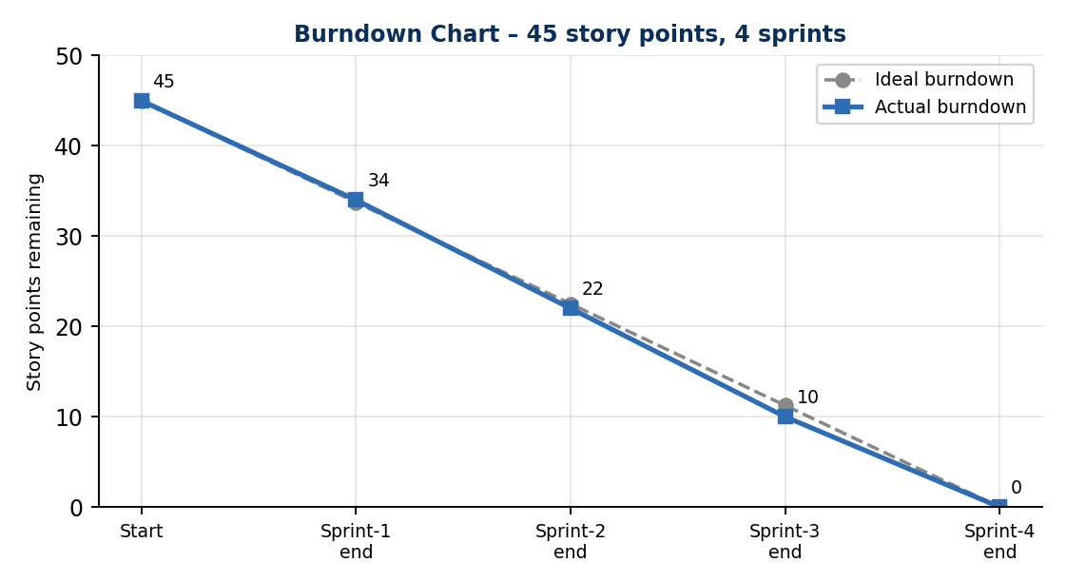
https://www.visual-paradigm.com/scrum/scrum-burndown-chart/
https://www.atlassian.com/agile/tutorials/burndown-charts
Reference:
https://www.atlassian.com/agile/project-management
https://www.atlassian.com/agile/tutorials/how-to-do-scrum-with-jira-software
https://www.atlassian.com/agile/tutorials/epics
https://www.atlassian.com/agile/tutorials/sprints
https://www.atlassian.com/agile/project-management/estimation
https://www.atlassian.com/agile/tutorials/burndown-charts

